

Systematic Review on the performance of hospitals assessing the quality and the social impact of healthcare professionals

**Participants of the group:**

Camilla Lombardi 1794467

Clemente Recine 1800656

Alessandro Taglieri 1890945

Lorenzo Garcia Condoluci 1808446

# 

# Index

**Abstract** **2**

**Introduction** **2**

**Method** **2**

Design 2

Literature Search 3

Search Outcome 6

Eligibility criteria 6

Table of Included Studies 7

**Results** **10**

**Discussion** **10**

Common points 10

Differences 11

Limitations of our study 11

**Conclusions** **11**

**Bibliographic References** **12**

# **Abstract**

**AIM:** The aim of this systematic review is to identify the factors through which we can assess the quality of healthcare assistants and how this reflects on the hospitals.

**BACKGROUND:** The worldwide health condition prompted us to analyze the importance of the quality of nurses and how much patients are satisfied with it.

**METHOD:** Relevant articles were found using the literature database SCOPUS. A systematic review, based on the PRISMA Model, was conducted. We visualized the main features thanks to VOSViewer software.   
**RESULTS:** Three main themes were identified: *the importance of relationships*, *where does quality come from*, *both patients and nurses satisfaction*.

**CONCLUSIONS:** Research provided insight on the main aspects in order to improve the quality of hospitals.

# **Introduction**

As the COVID-19 induced world pandemic continues, hospitals and healthcare professionals struggle to keep up with the increasing difficulties posed by the ongoing situation. This systematic review presents itself as an analysis of how hospitals and healthcare professionals adjourned and evolved themselves from 2018 to today in order to observe the main factors that influence the quality and the social impact of healthcare professionals. Hospitals are definitely a perfect framework of analysis where the general performance is directly connected to the performance of each human being working in it.

The reason why we worked on such a topic is that we wanted to research the positive impact that nurses do have on patients and on their recovery. We decided to focus on the time period between 2018 and nowadays and to consider only the more developed countries (like United States, Canada, European countries, etc.) to have a similar framework of hospital structures and nurses education.

# **Method**

## Design

This systematic review is based on the totality of information gained during the course of Quantitative Models for Economic Analysis and Management held at Sapienza University of Rome (Data Science MSc) by Cinzia Daraio (A.Y. 2020-2021):

1. Provided slides specifically on how to structure a systematic review;
2. Seminar of the 08 April 2021 held by Thyago C. Nepomuceno “Methodological Tools For Network and Mapping of Bibliometric Landscapes”;
3. Seminar of the 15 April 2021 held by Simone Di Leo “PRISMA Model In Action - Systematic review of university performance using intellectual capital”;

## 

## Literature Search

The literature search was conducted on SCOPUS using the following query:

TITLE-ABS-KEY( (hospital*) OR (clinic) )

AND TITLE-ABS-KEY ( (assess* AND qualit*) AND (human AND action) )

AND TITLE-ABS-KEY ( (perform*) OR (reliabilit*) OR (value*) OR (suppl*)

OR (facilit*) OR (fornitur*) OR (innovat*) OR (research*)

OR (universit*) OR (surger*) )

AND PUBYEAR > 2017 AND ( LIMIT-TO ( LANGUAGE, “ENGLISH”) )

Let us see some statistics on the 649 articles we retrieved from scopus.com:

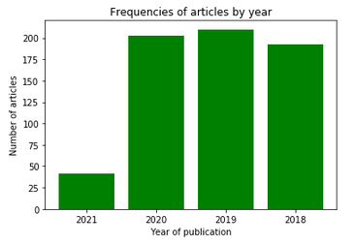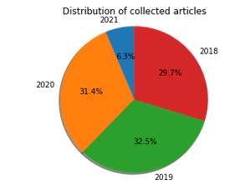

It can be clearly seen that the number of the articles published per year is evenly distributed between 2018 - 2021, while (quite obviously given that we are writing this systematic review in April 2021) the articles dated 2021 are a minority.

We then use VOSviewer to analyse some interesting characteristics.

Given that we decided to focus our analysis on more developed countries, we thought it would be interesting to see the geographical distribution using the following parameters:

* type of analysis: co-authorship
* unit of analysis: countries
* counting method: fractional counting
* max_number_countries = 25
* min_number_documents = 5

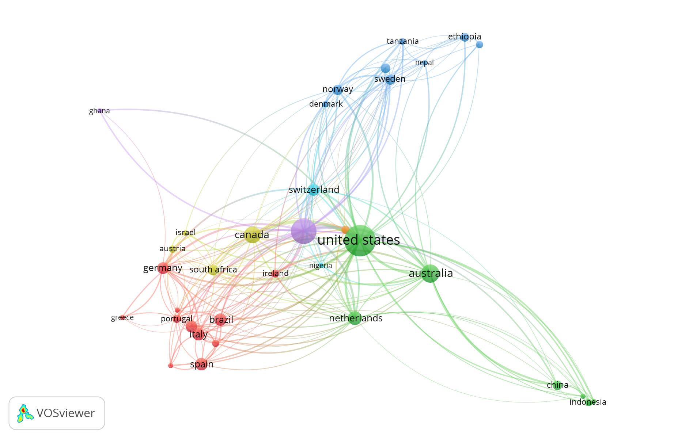

Furthermore, we decided the analyse the keywords in the 649 retrieved articles using the following parameters:

* type of analysis co-occurrence
* unit of analysis: author keywords
* counting method: fractional counting
* min_number_occurrences_keyword = 5

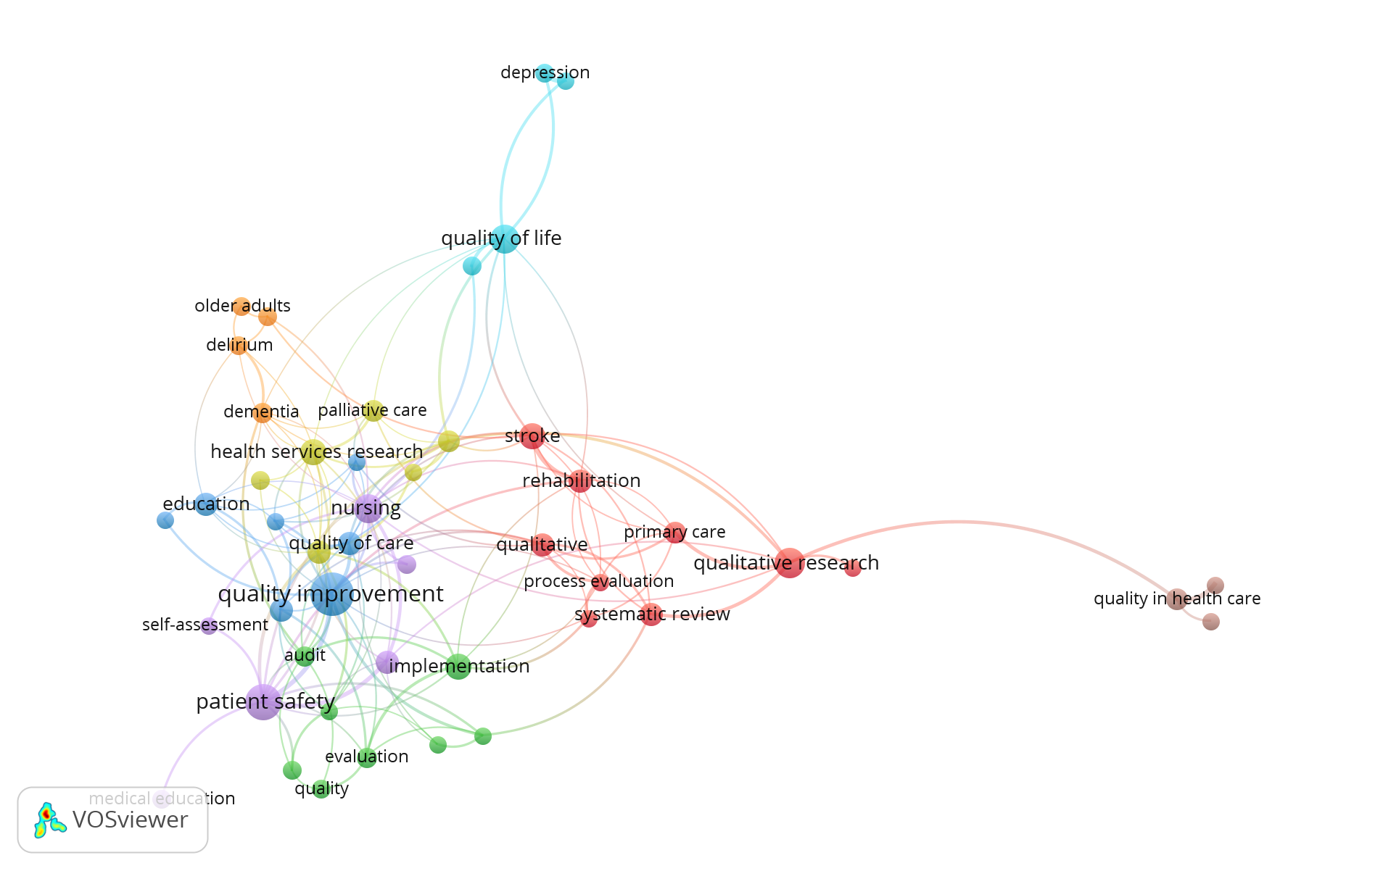

After having deeply analysed the structure of the relationship between the given keywords, the participants decided to give a more specific focus to the systematic review. In fact, we decided to prioritize aspects like “nursing”, “quality improvement”, “patient-safety”.

We will better see in the chapter on eligibility criteria the specific considerations we made to decide whether a paper is or is not eligible for the purpose of this systematic review.

As anticipated, our review will focus on developed countries. The following is a graph showing the relationship between the countries that were considered developed countries. This decision was based on “The 2019 Human Development Report by the United Nations Development Programme” which was released on 9 December 2019 and calculates HDI (Human Development Index) values based on estimates for 2018.

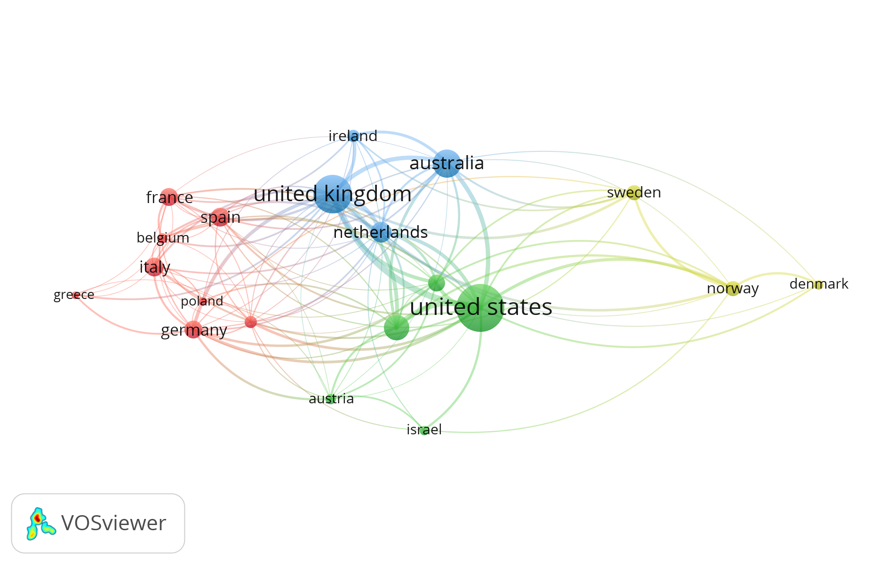

We are going to consider 20 countries that can be clustered into 4 clusters. It is interesting to notice how the United States and the United Kingdom are the most relevant and more strongly related nodes in the graph.

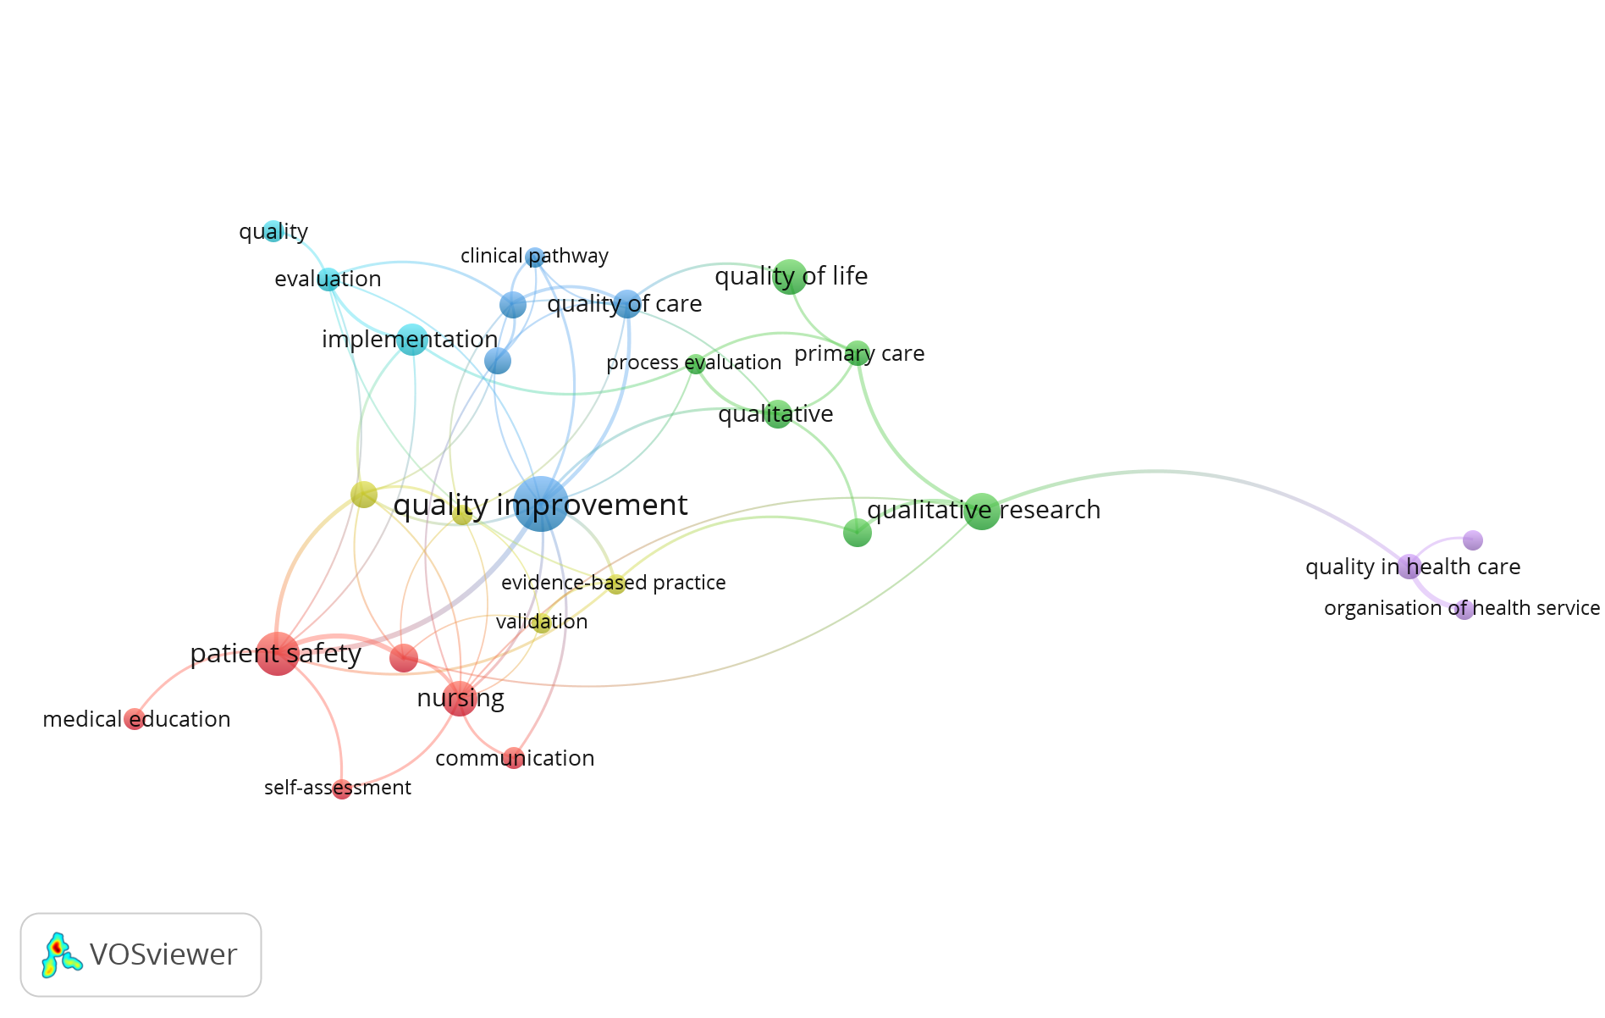

This graph highlights the keywords we are going to take into account due to the fact that they do possess the qualifying criteria to be considered in the systematic review.

## Search Outcome

The initially retrieved articles were 649. We then used Raynann to select all those articles that presented either in the title or in the abstract the selected keywords and that were relevant to the topic. Each paper needed to be labelled giving both reasons for the inclusion and the exclusion. Notice that we decided to focus only on those articles that were relevant to more developed countries. This decision was supported by the whole group because we believe that considering the quality of healthcare provided in both third-world countries and in rapidly emerging countries would have needed a different study design because they are not comparable to hospitals in developed countries.

This type of selection was made in a collaborative manner by dividing equally the workload between the team members (around 160 articles each). Once everyone had read the assigned papers, each one of us reviewed (1) the ones that were classified as a “maybe”, (2) the ones that were classified as ”relevant” from one of the team members. At the end of this process, the returned pool of papers counted 29 articles. All the abstracts of the considered essays were then read by at least one member to check that the content of the articles was not equal or similar.

### Eligibility criteria

The following are the eligibility criteria the participants used to determine whether an article is qualified to be included in the systematic review. In order to assess their eligibility, each one of the 29 articles has been read and discussed by the entire group.

Some of the papers had as main topic how nurses dealt with specific diseases or patients with particular conditions. We decided to not consider them as they were too specifically inherent to such diseases and therefore not coherent with our aim. Other papers were found to reference either countries that we did not include in our analysis (but it was not explicitly declared in the abstract) or that they focused on a population coming from such countries. Just one paper was not eligible because it did not present any results and was just an introduction to a specific framework of analysis that the authors would like to assess in the near future.

The PRISMA Flow Diagram we can find on this page summarizes the most important steps that were undertaken in order to decide the articles that needed to be included in the systematic review.

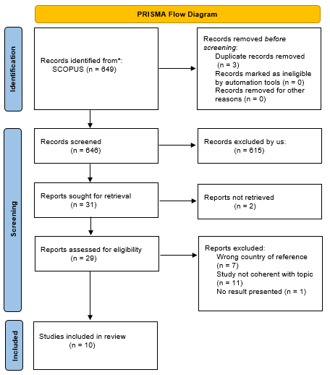

## Table of Included Studies

This table does contain the most important information about the articles that have met the eligibility criteria set by the group.

|  |  |  |  |  |  |  |
| --- | --- | --- | --- | --- | --- | --- |
| **Articles** | **Author(s) (year) and location** | **Aim** | **Type of article** | **Methodology** | **Sample size** | **Findings** |
| **#1** | Pleh D.N., Rosted E., Thomsen T.G.  (2021), Denmark | Identify key competence of outpatients nurses as perceived by patients | Systematic review | Integrative review inspired by Whittermore and Knafl's methodology. |  | Main key competences found were providing access, sharing knowledge and establishing relationships. |
| **#2** | Eskin Bacaksiz F., Alan H., Taskiran Eskici G., Gumus E.  *(2020), Turkey* | To analyze missed nursing care in a sample of private hospitals. | Paper | Survey coming from 897 nurses. | 897 | Measurements of the missed nursing care statistically differed in terms of nurses’ gender, weekly work hours, overtime work and perception of nurse adequacy, and the hospital's accreditation status. |
| **#3** | Stotts J.R., Lyndon A., Chan G.K., Bekmezian A., Rehm R.S.  *(2020)* | The purpose of this integrative review was to synthesize the findings of studies that examined factors that influence in-hospital pediatric nurses in non-ICU environments when confronted by clinical deterioration. | Systematic review | A search of the CINAHL, PubMed, and Web of Science databases was conducted in January 2019 by JRS for English-language research published up to December 31, 2018 that was filtered for human and child, birth to 18 years |  | All of the studies reviewed used non-experimental designs. Six themes associated with the aims of this research were derived through iterative and constant comparison: Assessing and documenting, Decision making, Communicating changes in patient conditions, Intervening, Relationships between team members, Parents as partners in surveillance. |
| **#4** | Fassarella C.S., da Silva L.D., Camerini F.G., Barbieri-Figueiredo M.D.C.  *(2019), Portugal* | Evaluate the organizational safety culture of a Portuguese university hospital on the basis of nurses’ perceptions | Paper | Survey on Patient Safety Culture instrument | 567 | Teamwork between units and supervisor expectations and actions promoting patient safety lead to better;  Manager should aim to a safety culture based on transparency, trust, organizational learning and communication of errors instead of a punitive culture |
| **#5** | Colldén Benneck J., Bremer A  *(2019), Sweden* | To explore registered nurses' experiences and behaviours associated with near misses where patient safety in the ambulance service was jeopardized | Paper | Based on critical incident technique, a retrospective and descriptive design with individual qualitative interviews was used. |  | Seventy-three critical incidents of near misses constituted four main areas: Drug management; Human-technology interactions; Assessment and care and Patient protection actions |
| **#6** | Barbara King, Kristen Pecanac, Anna Krupp, Daniel Liebzeit, Jane Mahoney  *(2018), Wisconsin US* | Explore nurses' experience with fall prevention and impact of those experiences on how nurses provide care to fall risk patients (zero falls). | Paper | Grounded Dimensional Analysis, 22 interviews, focus group (5) | 22 | Restricting fall risk patients as a way to stop messages and meet the hospital goal |
| **#7** | Gro Hovland, Dagrun Kyrkjebo, John roger Andersen, Maj Britt Raholm  *(2018), West part of Norway* | Nursing competence in Norway | Paper | Norwegian version of the Nurse Competence Scale (NCS) instrument, describes the quality of action on this scale with values 0-25, 26-50, 51-75, 76-100 low, moderate, good and very good quality. | 89 | Competence is situationally and socially related, with educational level |
| **#8** | Janet Phillips, Ann Stalter, Sherri Winegardner, Carol Wiggs, Amy Jauch  *(2018), USA* | *What ST evidence fosters the effect of workplace civility in practice settings?* | Systematic review | Five stage method (Whittemore and Knafl) |  | Five categories emerged revealing themes surrounding incivility in practice. The categories include (1) general incivility, (2) workplace incivility, (3) incivility in nursing practice, (4) suggestions to improve civility for nurses in practice, and (5) systems/ST and incivility in nursing practice. |
| **#9** | Patricia S. Groves | Jacinda L. Bunch  *(2018), Iowa* | The aim of this paper is discussion of a new middle‐range theory of patient safety goal priming via safety culture communication. | Paper | Discussion |  | Given the complex healthcare environment, continual staffing challenges, and limited fiscal resources of healthcare organizations, hospitals must be open to new methods of promoting patient safety and increasing the quality of healthcare encounters. |
| **#10** | Sarah Sims, mary Leamy,Nigel Davies, Katy Schnitzler, Ros Levenson, Felicity mayer, Robert Grant, Sally Brearley, Stephen Gourlay, Fiona Ross,6 Ruth Harris1  *(2018), UK* | Synthesis of the evidence on IR to develop IR programme theories of what works better | Systematic review | A three-stage literature search and a stakeholder consultation event was completed. |  | The synthesis identified a number of discrepan- cies between how IR is purported to work and how it operates in practice, as well as international differ- ences in how the intervention has been implemented. |

# **Results**

Given the focus of our systematic review, ten papers met the declared eligibility criteria. Five studies were systematic reviews, three were cross-sectional studies, all using interviews and surveys for data collection, and finally, we had a GDA (Grounded Dimensional Analysis) and a discussion paper. Due to the fact that we decided to consider just developed countries, all the studies we analyzed were conducted in European countries (Norway, Sweden, Denmark, Portugal, Italy), UK, Turkey, Canada, the US, Australia. In the table of included studies, we summarized all the main information about the papers taken into account.

In this systematic review, three main themes were found: *the importance of relationships*, *where does quality come from*, *both patients and nurses satisfaction*. All these arguments are strongly related to both the topic of human action and the assessment of quality.

The included papers highlighted how much the relationship between patients and nurses is important to improve quality in caregiving and in the outcome of patients. We could see this focus both from the patients and the nurses perspective.   
However, relationships should also be established between nurses and hospital staff. The former has to meet the hospital’s goal, and this is not always so simple from the nurses’ point of view. The key point in this theme is that there has to be a very good communication between the hospital staff and nurses in order to ensure high quality, patient satisfaction and not too much stress for healthcare providers.

The papers also focus on where quality comes from. This theme is present in almost all the studies we have considered to be eligible and is linked with the topics of competences, “civility”, the feeling at ease of nurses. Competences not only come from the educational level, but also from the teamwork between units and supervisors and on the fact that there should be a safety culture based on trust, organizational learning and communication of errors instead of a punitive culture (Fassarella C.S., da Silva L.D., Camerini F.G., Barbieri-Figueiredo M.D.C., 2019).

These two main topics are strongly related to each other and they conduct to both patients and nurses satisfaction. In a non-stressful situation, nurses work better and improve health care safety and high-quality performances which can lead to good outcomes for patients.

# **Discussion**

The aim of this analysis was to show how hospitals and healthcare professionals adjourned and evolved themselves from 2018 to today in order to observe the main factors that influence the quality and the social impact of healthcare professionals.

## Common points

The three main highlighted themes identify the importance of competences both as a personal ability to perform well and as the result of cooperation between hospital staff and nurses. Common to all papers was that not only the quantitative data was important but also the environmental variables had a strong impact on health care professionals and on their performance.

Another aspect that has been emphasized by all studies is the fact that one of the most important key points is communication. Communication both between nurses and patients and nurses and hospital staff is fundamental as this idea leads to a quality improvement in nurses' jobs. We can observe that this aspect has been stressed by all eligible papers even if the geographical and social context the original analysis was performed in differs.

## Differences

While the papers we analysed for this systematic review mostly concern themselves with surveys handed to nurses, where the focus was to assess their satisfaction with hospital policies and how working in a safe environment affects their work, in some of the systematic reviews we do consider (Pleh D.N., Rosted E., Thomsen T.G., 2021), surveys were addressed to patients in order to assess the quality of their healthcare providers.

Moreover, the aim of the analysis conducted might differ between different papers. Some of the articles analyze technical aspects of nurses’ daily work which could improve their efficiency optimizing aspects like the roundings and surveillance measures, while others do focus on interpersonal relationships between nurses and hospital staff or between nurses and patients.

## Limitations of our study

Our choices of including only very recent studies (from 2018 to 2021) and the geographical limitations we imposed, may have affected our analysis. It is not ensured that developed countries, even if they have very similar health systems, have a higher quality than less developed countries.

Furthermore, cultural and social phenomena may influence the health care that a country provides, also in the cluster of developed countries.

# **Conclusions**

This systematic review is a qualitative analysis. We can clearly infer that communication is a fundamental aspect in a hospital framework to better both the performances and the social impact of nurses, but it is not clear how communication should be implemented.

The participants have found interesting the fact that academic education of healthcare professionals was only considered in one of the articles while they do believe that it is an important aspect that might influence positively the quality assessment.

Furthermore, we are aware that, given the limitations we imposed, we might not have considered many features that could be relevant to the purpose of this systematic review.

Further research is needed to better understand this topic and to assess how to effectively improve the quality and the performances of healthcare providers. It would also be interesting to actually consider what we have categorized as “less developed countries” and actually see how they do perform on the topics this systematic review is centred on.

# **Bibliographic References**

(Pleh D.N., Rosted E., Thomsen T.G.) *Key competences of outpatient nurses, as perceived by patients attending nurse-led clinics – An integrative review;* 2021

(Eskin Bacaksiz F., Alan H., Taskiran Eskici G., Gumus E.) *A cross-sectional study of the determinants of missed nursing care in the private sector: Hospital/unit/staff characteristics, professional quality of life and work alienation;* 2020

(Subramani S. ) *The Social Construction of Incompetency: Moving Beyond Embedded Paternalism Toward the Practice of Respect;* 2020

(Geerligs L., Shepherd H.L., Rankin N.M., Masya L., Shaw J.M., Price M.A., Dhillon H., Dolan C., Prest G., Andrews G., Baychek K., Beale P., Allison K., Clayton J., Coll J., Cuddy J., Girgis A., Grimison P., Hack T., Kelly B., Kirsten L., Lindsay T., Lovell M., Luckett T., Murphy M., Newby J., Orr F., Pearce A., Piro D., Shaw T., Stubbs J., Viney R., White F., Yim J., Butow P.) *The value of real-world testing: A qualitative feasibility study to explore staff and organisational barriers and strategies to support implementation of a clinical pathway for the management of anxiety and depression in adult cancer patients;* 2020

(Liou S.-R., Liu H.-C., Tsai S.-L., Chu T.-P., Cheng C.-Y.) *Performance competence of pregraduate nursing students and hospital nurses: A comparison study;* 2020

(Fowler S.B.) *Critical-care nurses' perceptions of hope: Original qualitative research;* 2020

(Bakhtiari S., Rakhshan M., Shahriari M., Sharif F.) *Perspective and experience of operating room personnel on ethical behaviors;* 2020

(Stotts J.R., Lyndon A., Chan G.K., Bekmezian A., Rehm R.S.) *Nursing surveillance for deterioration in pediatric patients: An integrative review;* 2020

(Quaye A.A., Coyne I., Söderbäck M., Hallström I.K.) *Children's active participation in decision-making processes during hospitalisation: An observational study;* 2019

(Kakemam E., Kalhor R., Khakdel Z., Khezri A., West S., Visentin D., Cleary M.) *Occupational stress and cognitive failure of nurses and associations with self-reported adverse events: A national cross-sectional survey [护士的职业压力和认知障碍以及与自我报告不良事件的关系:一项全国性的横断面调查];* 2019

(Colldén Benneck J., Bremer A.) *Registered nurses’ experiences of near misses in ambulance care – A critical incident technique study;* 2019

( Manoppo I.A., Banna T.) *The completeness of nursing care documentation in Fakfak hospital;* 2019

(Maessen K., van Vught A., Gerritsen D.L., Lovink M.H., Vermeulen H., Persoon A.) *Development and Validation of the Dutch EBPAS-ve and EBPQ-ve for Nursing Assistants and Nurses with a Vocational Education;* 2019

(Ratsch A., Sewell F., Pennington A.) *Developing and testing a matrix to achieve ready-everyday nursing standards (RENS): An observational study protocol;* 2019

(Wood C., Chaboyer W., Carr P.) *How do nurses use early warning scoring systems to detect and act on patient deterioration to ensure patient safety? A scoping review;* 2019

( Birgand G., Haudebourg T., Grammatico-Guillon L., Ferrand L., Moret L., Gouin F., Mauduit N., Leux C., Le Manach Y., Lepelletier D., Tavernier E., Lucet J.-C., Giraudeau B.) *Improvement in staff behavior during surgical procedures to prevent post-operative complications (ARIBO2): Study protocol for a cluster randomised trial;* 2019

(Been-Dahmen J.M.J., Beck D.K., Peeters M.A.C., Van Der Stege H., Tielen M., Van Buren M.C., Ista E., Van Staa A., Massey E.K.) *Evaluating the feasibility of a nurse-led self-management support intervention for kidney transplant recipients: A pilot study;* 2019

(Patrone C., Cassettari L., Giovannini F., Cremonesi P., Cevasco I.) *Study and implementation of a performance set of indicators for the nurse manager in a frailty hospital;* 2019

(Fassarella C.S., da Silva L.D., Camerini F.G., Barbieri-Figueiredo M.D.C.) *Organizational indicator of safety culture in a university hospital [Indicador organizacional da cultura de segurança em um hospital universitário] [Indicador organizacional de la cultura de seguridad en un hospital universitario];* 2019

(Drach-Zahavy A., Leonenko M., Srulovici E.) *Towards a measure of accountability in nursing: A three-stage validation study [实现护理责任的衡量标准:分三阶段验证研究];* 2018

(Groves P.S., Bunch J.L.) *Priming patient safety: A middle-range theory of safety goal priming via safety culture communication;* 2018

(Kouatly I.A., Nassar N., Nizam M., Badr L.K.) *Evidence on Nurse Staffing Ratios and Patient Outcomes in a Low-Income Country: Implications for Future Research and Practice;* 2018

(Sims S., Leamy M., Davies N., Schnitzler K., Levenson R., Mayer F., Grant R., Brearley S., Gourlay S., Ross F., Harris R.) *Realist synthesis of intentional rounding in hospital wards: Exploring the evidence of what works, for whom, in what circumstances and why;* 2018

(Travers C., Henderson A., Graham F., Beattie E.) *CogChamps: Impact of a project to educate nurses about delirium and improve the quality of care for hospitalized patients with cognitive impairment;* 2018

(Bloodworth L.C., Parenti K., Fralix J., Smith M.) *Using Quality Measures for Performance Improvement in the Skilled Nursing Facility/Long-Term Care Setting;* 2018

(Phillips J.M., Stalter A.M., Winegardner S., Wiggs C., Jauch A.) *Systems thinking and incivility in nursing practice: An integrative review;* 2018

(Hovland G., Kyrkjebø D., Andersen J.R., Råholm M.-B.) *Self-assessed competence among nurses working in municipal health-care services in Norway;* 2018

(Mohanaruban A., Flanders L., Rees H.) *Case-based discussion: perceptions of feedback;* 2018

(King B., Pecanac K., Krupp A., Liebzeit D., Mahoney J.) *Impact of Fall Prevention on Nurses and Care of Fall Risk Patients;* 2018

(Parsons K., Gaudine A., Swab M.) *Older nurses' experiences of providing direct care in hospital nursing units: a qualitative systematic review;* 2018

Page MJ, McKenzie JE, Bossuyt PM, Boutron I, Hoffmann TC, Mulrow CD, et al. The PRISMA 2020 statement: an updated guideline for reporting systematic reviews. BMJ 2021;372:n71. doi: 10.1136/bmj.n71

https://en.wikipedia.org/wiki/Developed_country